Name:- Pal
Roll_no:- 06
Div:- C

Lab – 07
Title: Deploying Prometheus and Grafana on EC2 for Monitoring Applications
Objective:

To deploy Prometheus and Grafana on an Amazon EC2 instance and set up a basic open-source monitoring stack to visualize application and system metrics.

Duration:
Approximate time taken to complete the lab: 2 Hours

Pre-requisites:
- AWS Free Tier account
- EC2 key pair
- SSH access (TCP 22), Prometheus (TCP 9090), Grafana (TCP 3000)
- Basic Linux CLI knowledge

Lab Steps:

Part A – Launch EC2 Instance
- Launch Amazon EC2 instance (Amazon Linux 2 or Ubuntu)
  - Instance type: t2.micro
  - Inbound rules:
    - TCP 22 (SSH)
    - TCP 9090 (Prometheus)
    - TCP 3000 (Grafana)
  - Tag name: monitoring-node
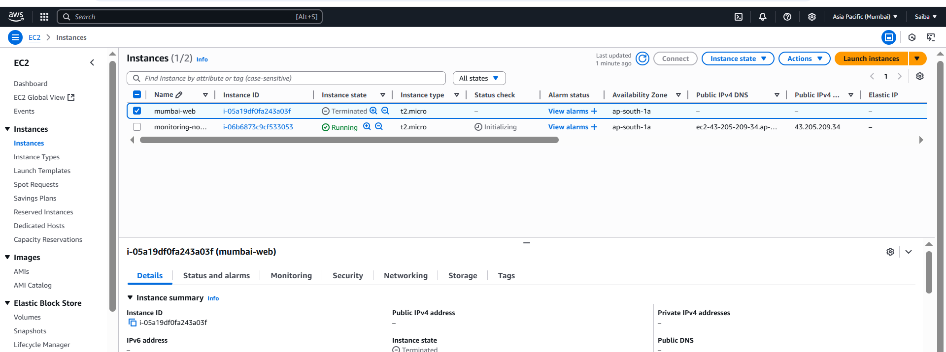
- Connect via SSH:

📸 Screenshot 1: EC2 instance launched

Part B – Install Prometheus
- Create user and download Prometheus:
sudo useradd --no-create-home --shell /bin/false prometheus
cd /opt
sudo curl -LO https://github.com/prometheus/prometheus/releases/download/v2.52.0/prometheus-2.52.0.linux-amd64.tar.gz
sudo tar -xvf prometheus-2.52.0.linux-amd64.tar.gz
sudo mv prometheus-2.52.0.linux-amd64 prometheus
- Configure prometheus.yml:
scrape_configs:
- job_name: 'prometheus'
static_configs:
- targets: ['localhost:9090']
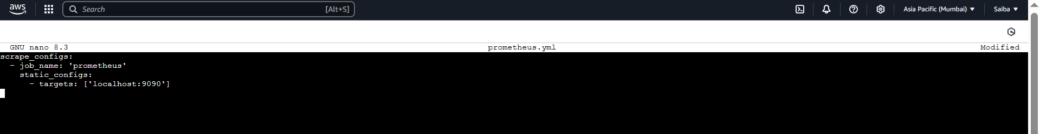
- Run Prometheus:
cd /opt/prometheus
./prometheus --config.file=prometheus.yml &
- Access at: http://<EC2-PUBLIC-IP>:9090
